# Assignment 2 Design Document

**Account Information**

|  |  |
| --- | --- |
| **Username** | **Password** |
| user1 | pass1 |
| user2 | pass2 |
| user3 | pass3 |
| user4 | pass4 |
| user5 | pass5 |

|  |  |
| --- | --- |
| **Groups** | **Members** |
| Group1 | user1, user2, user3 |
| Group2 | user1, user4, user5 |

**Changes to form page**

1. Form is now broken into pages instead of displaying the whole form.
   * User can navigate between pages with a bootstrap control.
   * The “slick” carousel plugin is used to switch between form pages.
   * Jquery is used to display the set program name and term for change at the top of the form (this helps the user to see what program request he/she is working on without navigating to previous pages)

*\* Jquery was used to implement the slick carousel*

1. Form has validation to determine if the program name has been entered and if it does not already exist in the database before submission
   * The check to see if the program name exists is done on the server by querying the database with the entered program name and checking if results are found
   * The check to see if program name is blank is done on the server as well as being checked on the client using the plugin “validetta”

*\*Jquery is used to validate on the client, and php is used to validate on the server*

**With JavaScript**

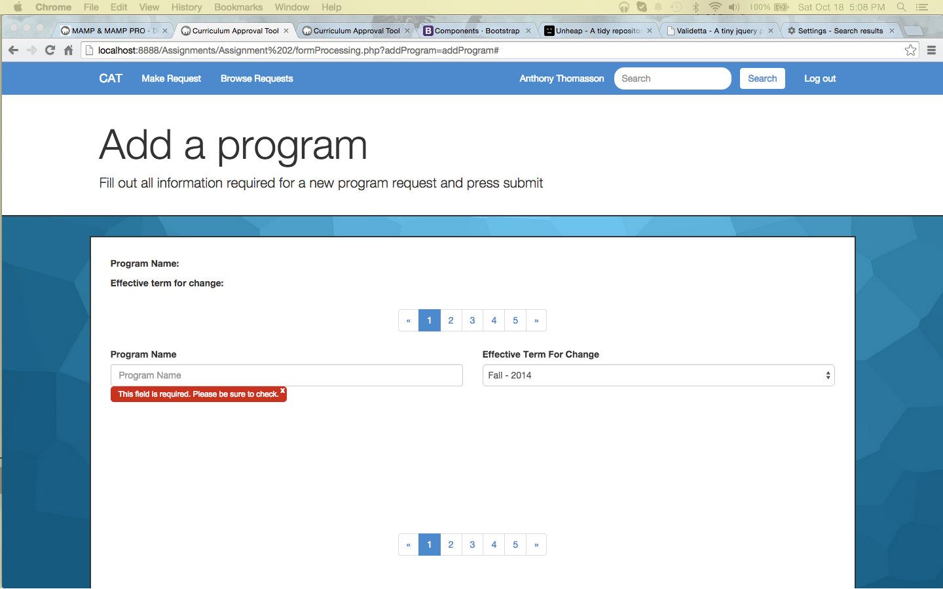

**Without JavaScript**

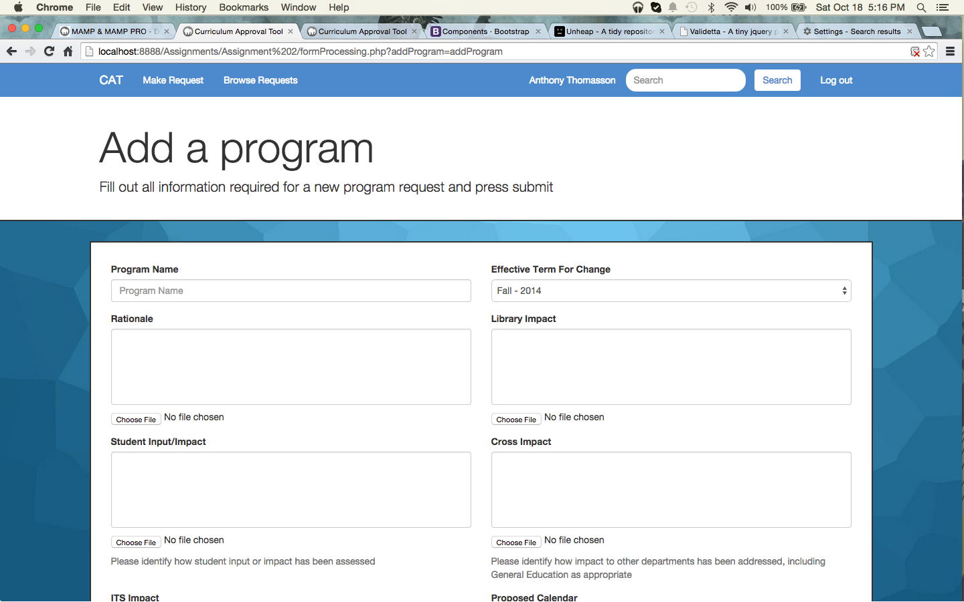

**Changes to search results**

1. All search results can now be sorted by clicking the column heading in the results table.
   * The “TableSort” plugin is used to sort the data with an animation showing each row changing to the correct order

*\* Jquery was used to implement the sort*